Issues in historiography: Telling History through film
Film can provide an accessible means to complex historiographical debates. The figure of Hitler and his role in the Nazi state has been a hotly contested issue in history.
Example: Downfall (2005) directed by Oliver Hirschbiegel
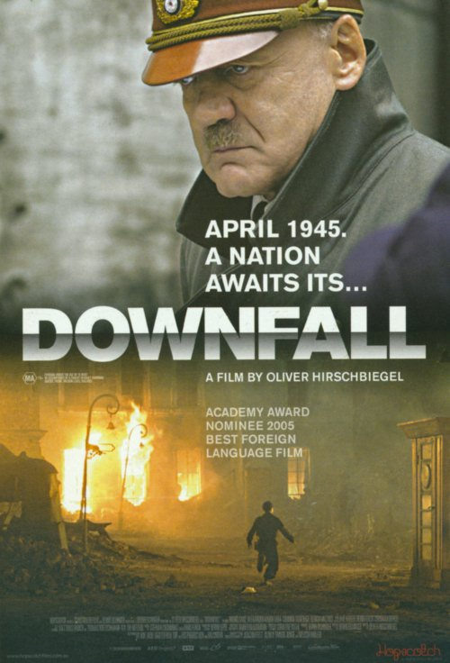
The opening 20 minutes of the film
Comment on your impressions of the film and the way in which it represents history around the following historiographical issues:
- How are the viewers encouraged to trust the historicity of the film?

- What is the impact of the film’s opening? Why does the director choose to open it in this way?

- How are we positioned to view:
  - The issue of individual responsibility for Nazi atrocities?

  - The “truth” of the film?

- Whose perspective is offered by the film?

- “the more you talk about the horrors of a war, the more you are less likely to try to get involved in another one” Do you think that this statement has some degree of truth? In which case, what is the role of history and historians?

- To what extent does the film “humanise” Hitler? Why? Consider the debate about whether Hitler should be interpreted as a “monster” /“psycho” or as an evil, but sane human being.

- Comment on the focus of the film and the temporal and topical scale on which historical events and personalities are examined.

- Contrast Scene 1 and 2. Why is this effective? What is suggested about the nature of the war in the 2 and a half years that elapsed? Why has the filmmaker chosen to omit this period?

- How effective is film as a form of historical communication?

- What type of history is represented?

The opening 20 minutes of the “Making-of” documentary
Comment on the historiographical issues raised in the documentary:
- What made the film special according to the scriptwriter?

- Why doesn’t the scriptwriter see the film as a “microcosm”? What does he say it is instead? Why?

- What is the objective of the film according to the script writer?

- What comments are made about the use of historical time in the film?

- What is the historical context of this film? Who is the filmmaker?

- Why did the director accept the role? What insight do we have into his perspective and purpose?

- Why did Ganz accept the role of Hitler? What comments does he make about how Hitler has been previously been represented on film? What are the moral issues at stake in playing Hitler?

- Identify some of the sources used in the making of the film. Is there factual evidence to support this interpretation of the events and personalities?

- How has the filmmaker interpreted the role of history?

- What are the strengths/weaknesses of this film as a source?

The Nature and Study of History by Henry Commager
How are these ideas reflected in Downfall and its “Making –of” documentary?
- “History is organised memory”

- “History is a story”

- “History is art”

- “it [history] is interpretation”

- “the great preservative in history, as in all else, is style.” How is style important in Downfall?

- “The literary historian employs his talents to conjure up what was once real and is now no more, and to excite the imagination of the beholder to see the past through his eyes” How is this idea articulated in the “Making-of” documentary?

- What are Commager’s three pleasures of history?

- Are any of these used to “sell” the historicalness of the “making-of” Downfall?

Homework Task:
Choose an example of popular history.
- It could be a film that tells history (and one where the DVD has a “making of” section). Suggestions: Amazing Grace, The Motorcycle Diaries, The Last Samurai, Cold Mountain, Gladiator, Saving Private Ryan, Kingdom of Heaven, Troy, Rabbit Proof Fence, Elizabeth, The Patriot, Braveheart, The Alamo, Glory
- It could be a historical documentary. Examples include: Utopia Girls, Immigration Nation, First Australians, The American Civil War (Ken Burns), The Fog of War, Dirty Business: The Story of Mining in Australia (2013), Simon Shama’s, A History of Britain (2002), Jeremy Paxman’s, The Empire (2012), Shoah (2003)
- It could be an example of history on TV: an episode of Who do you think you are?, Picturing You
- It could be an example of history on radio:
Suggestions: ABC Hindsight- http://www.abc.net.au/radionational/programs/hindsight/
A History of the World in 100 Objects, BBC Radio 4 http://www.bbc.co.uk/ahistoryoftheworld/
fBi has a weekly history program, called ‘Scratching Sydney’s Surface’ – see their blog here: http://scratchingsydneyssurface.wordpress.com/about/
- It could be an example of history online:
Dictionary of Sydney http://home.dictionaryofsydney.org/
History pin http://www.historypin.com/
Google Cultural Institute, historic moments http://www.google.com/culturalinstitute/project/historic-moments
- It could be an example of history in the gaming world:
Brothers in Arms http://www.eurogamer.net/articles/2012-08-14-the-medal-of-honor-tomahawk
You will be evaluating this text and leading the class in a short discussion of the historiographical issues raised (Use the syllabus dot points!)
You will select a brief extract from the text chosen to show the class.
In making your presentation, you will need to address the following:
- What are the aims and purposes of popular history? Why and how does it choose to represent historical events/personalities?
- Describe the historical setting – on what scale is this work of history? How “realistic” or “truthful” is its representation?
- What is the role of the emotional or human element in the text?
- What aspects of this “recreated world” reflect the world of today or its values?

Presentations will occur on _______________________________

